**New Requirements**

**User Account**

1. Add city: where are athletes and coaches from.
2. User type: administrators/athletes/coaches in other cities
   1. Administrators (from Ottawa) can do anything and view all the data.
   2. Only administrators can delete user files.
   3. Coaches from one city can only create or modify data of the athletes from the same city.
   4. Create a field called athlete level (Elite /Competition /Recreational /General Fitness), which only administrator and coach can see, athletes could not see.
3. When user login, set a list (administrator/coach/athlete) for them to choose their characters.

**Test Result**

1. Not only 2 types (Running and Cycling) of test result, actually dozens of types. For every type, the input and output are totally different from others.
2. Administrators not only create and view test result, they can also modify all the test results.
3. Compare data with different month/year, with different people….Such as compare own data with people have same age or find all the 40-50 year old male weight loss clients who did a cycling test. Includes generating group report.
4. Change the description sections. Set test fields for administrators to input each the descriptions.
5. Only show the data we have in the table so that we don't have a bunch of blank spaces if we only do a zone check.

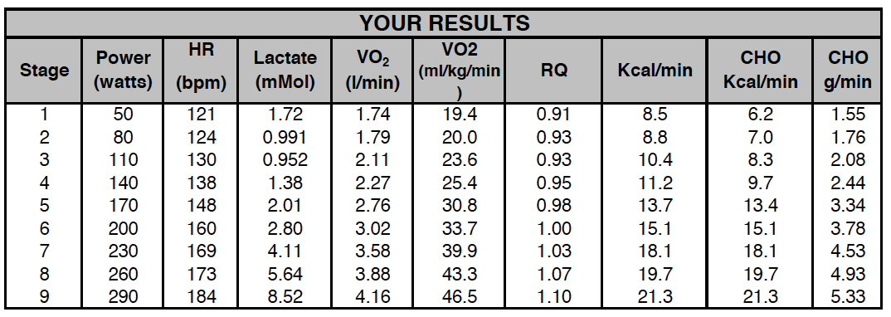

1. Generate numbers in the table automatically.

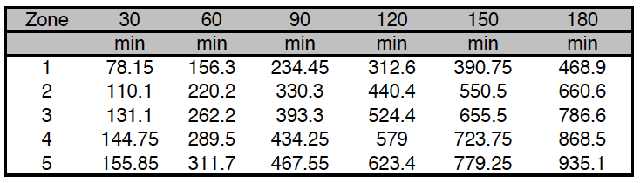

1. Generate numbers in the table automatically.

This part is also different from template to template, it should also input dynamically. Such as which columns (Power, HR, CHO…) they need, how many rows (zones) they need.

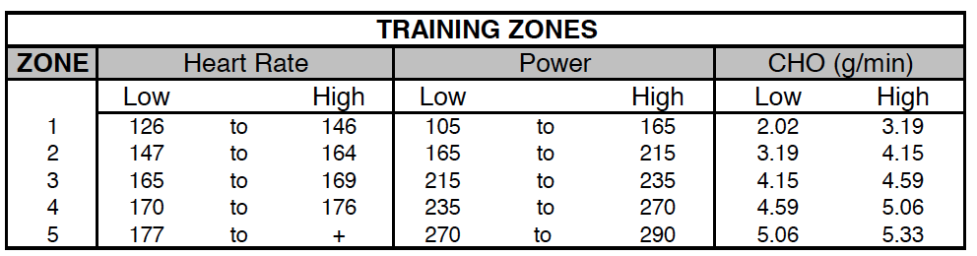

**Training Plan**

1. Every plan, not only 4 month plan, can be at least 1 week, unlimited.
2. Everyone can have 1 or more training plan, listed by date.
3. Training zones and test result should be shown in training plan.
4. Flexibility Training Images should be popped up if clicked.

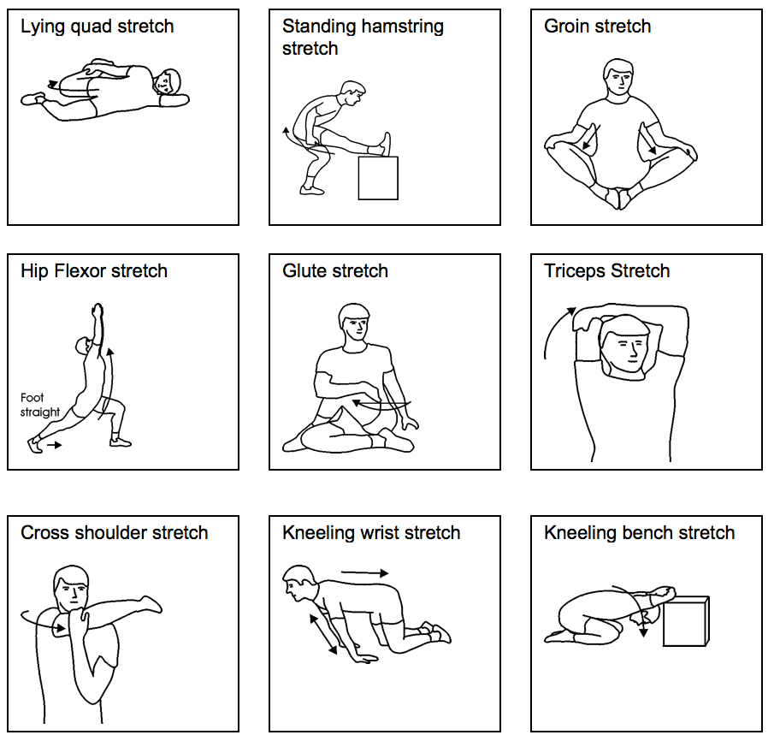

1. Ability to link video to the strength and flexibility programs so that clients who are not local can see demos.

**Workout Summary**

* If athlete does not finish the workout of that day, they want to drag and drop it to another day.
* Input every week summary, yes or no. If no, input the percentage they have finished.

**Ability to export the data to excel for further analysis**

To CSV file.